Natural language grammar often has many kinds of words; but the two most important kinds of words are nouns and verbs. The same is usually true of computer languages: there are things that we want to represent and process in some way and there are actions that we want to be be able to model.
The kind of UML-based analysis that we have used so far often leads naturally to a classification of the things in the DSL. Knowing what you want to do with those things may be harder to clarify. However, we have not finished with our use of UML.
One way of defining action, as illustrated in the UML diagram is:
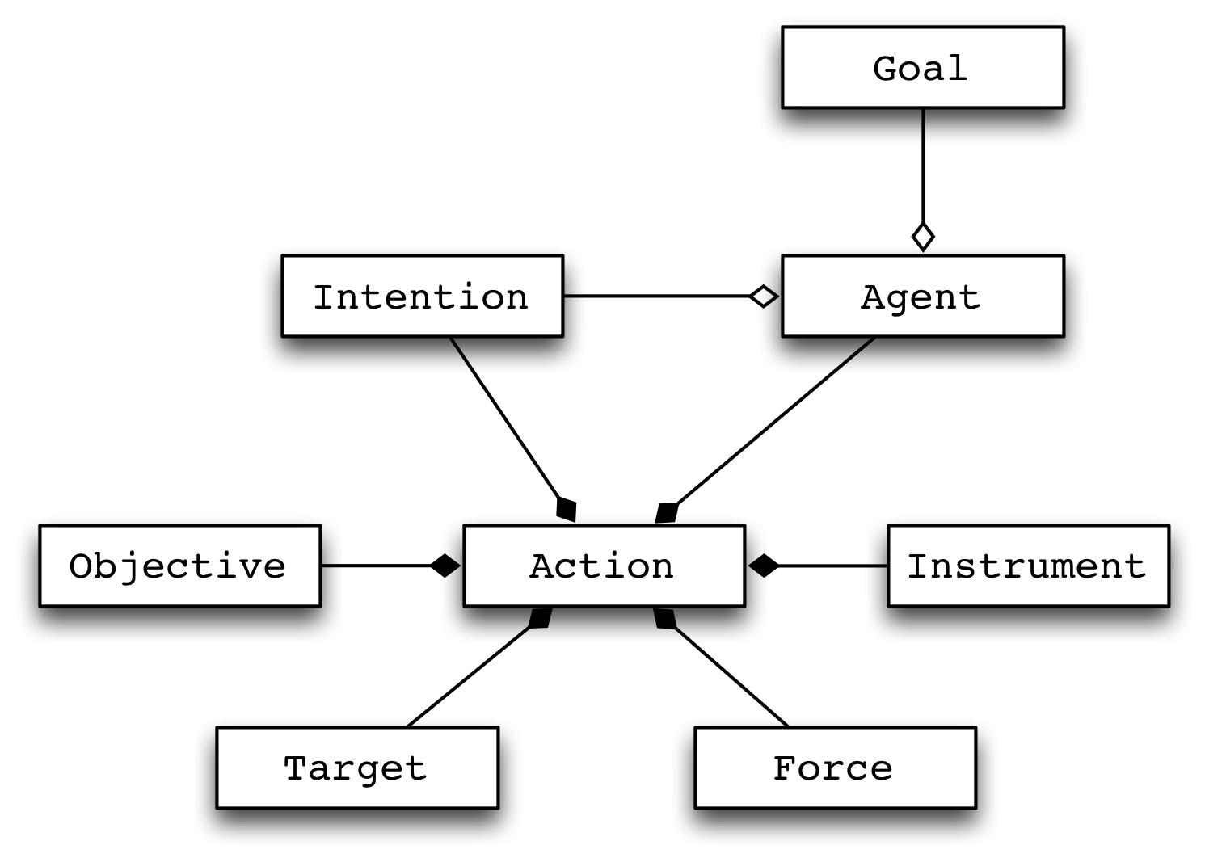
<$Scr_Ps::0>Ontology of Action
<!$Scr_Ps::0><$Scr_Ps::1>Action
<!$Scr_Ps::1><$Scr_Ps::2>An action is the intentional application of force to achieve an objective.
<!$Scr_Ps::2>Here, ‘force’ is intended to be broadly interpreted — it can include, for example, calling a function as well as lifting a rock.
Agency – itself a term that can be difficult to define – it core to the notion of action. If a tree in a forest falls on a squirrel and squashes it that was not an action because the tree did not (cannot) intend to fall on the squirrel: it has no agency for this class of action.
On the other hand, the jump the squirrel makes when it sees the tree falling is an action: it intends the application of force on the rock it was sitting on — in order to escape the falling tree.
This analysis of action is important because it gives us all kinds of hooks for designing the verbs in our DSLs. For example, a lot of object-oriented programming can be understood by letting the target of an action be a data value.
More generally, we have:
<$Scr_Ps::1>Target
<!$Scr_Ps::1><$Scr_Ps::2>The target of an action is the thing that is being operated on.
<!$Scr_Ps::2>Not all actions have an obvious target; for example, the true target in an e-mail marketing campaign is not the e-mail system but the human readers of e-mail.
<$Scr_Ps::1>Instrument
<!$Scr_Ps::1><$Scr_Ps::2>The instrument is the means by which the action is performed.
<!$Scr_Ps::2>In the case of the squirrel above, the instrument is the squirrel itself; in the case of calling an API it is the API method.
<$Scr_Ps::1>Force
<!$Scr_Ps::1><$Scr_Ps::2>The diversion of potential energy into actual work.
<!$Scr_Ps::2>This can be difficult to get one’s head around. Without force though, there is no action. In the case of a computer program, force amounts to execution: the action is performed when the corresponding program fragment is executed.
<$Scr_Ps::1>Agent
<!$Scr_Ps::1><$Scr_Ps::2>Agency is what distinguishes action from random events.
<!$Scr_Ps::2>There are many possible interpretations of agent; we shall see some of them in our chapter on communicating agents. The simplest form of agent in a programming language is simply the thread of control. However, if your DSL is about multiple threads or parallelism in some way, then you will likely need to focus on agent as a specific concept.
<$Scr_Ps::1>Intention
<!$Scr_Ps::1><$Scr_Ps::2>An internal state which is potentially causal for action.
<!$Scr_Ps::2>A key aspect of action is that it is intentional — or to put it counterfactually: an action is not an accident.
When designing a DSL, the verbs in the DSL that correspond to actions are normally some form of command. A command also pre-supposes an agent that issues the order.
What difference does this make? There may be other kinds of verbs that you will need in your DSL. For example, declaratives state something about what is (or should be) true. Declaratives are not actions; if for no other reason than declaratives are not associated with intention.
<$Scr_Ps::1>Objective
<!$Scr_Ps::1><$Scr_Ps::2>A measurable state — characterized by a predicate — that an agent seeks to achieve with an action.
<!$Scr_Ps::2>It is the objective that often gives the most concrete guidance in designing DSLs. There may be many objectives and any given objective may have many actions associated with it. However, if you list your actions’ objectives, then you may have the beginnings of a list of verbs.
Note that we make a distinction between objectives and goals. Agents have goals, actions have objectives. Goals can be viewed as desirable states of the world, an objective is a measurable state. Goals are often not directly observable; by their nature, objectives observable in principle — though not necessarily by everyone.
Objectives also allow us to distinguish between intended results and unintended effects.
Not all DSLs make all the features of an action explicit. However, the exercise of iterating through the different aspects of action will often lead to a clear conceptualization of the nouns and the verbs that form the core of the DSL.
In the case of our RDF language, the principal actions relate to store and recall. We need to be able to manipulate triple graphs and we need to be able to query them. Here, we focus on querying because that is core to the role of any knowledge store.

